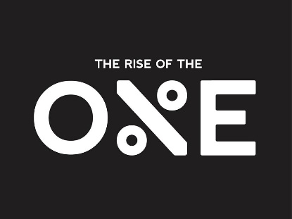
“How To Make 2021 Your Best Year Yet”
By: Creator & Founder Of The Rise Of The O%E
Gerald Bass

Spiritual:
1.)
2.)
3.)
4.)
5.)

Personal & Behavior Goals:
1.
2.
3.
4.
5.
Health & Fitness Goals:
1.
2.
3.
4.
5.
Business Goals:
1.
2.
3.
Accumulated Wealth Goals:
1.
2.
3.

Execution Plan For Business Goals:
What are the things you are going to do daily, weekly, and monthly to hit your business goals for 2021?
How will your schedule look daily?

