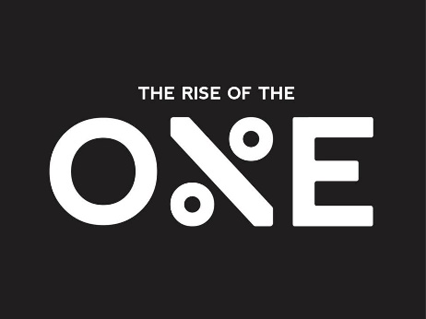
Sales Training Pt. 2
Convict
To Conquer.

A sale is made when your conviction and belief about something is stronger than others.

To achieve greatness you have to be unreasonable.

Why should someone go in debt to buy your product/service?
Why should someone purchase now than later?
Why should someone do business with you than another company?

90 Day Phenomenon- Not selling after 90 days of success caused by an individual being told to do something he/she no longer believes in.

Disagreement with what he/she selling.

Not selling is a form of selling!

Sell yourself all over again!
Do you own the product/service you sell?

4 Degrees Of Action
- Right Action
- Wrong Action
- No Action
- Massive Action
Go Big Or Go Home!

Go Massive Not Passive!

Always Agree With Your Customer
- Start the sale from agreement
- Continue to agree throughout
- Make the buyer right
- Close
Start the relationship off with agreement
Establishing Trust
Distrust is not the buyer’s problem
1.Trust is critical
2. If you don’t get the sale there is distrust
3. Every decision is a decision

No Trust= No Sale
No Credibility= No Sale

- Building Trust
- Keep Credibility

Without Credibility

- Lengthens the sales process
- Makes yourself less valuable
- Get shopped by your customers
People believe what they can see not what they can hear.

Be Credible + Trustworthy
- Use Data
- Show them proof
- Keep an evidence manual

Tips on Trust
- Don’t sell with words
Show documentation
- Never negotiate with words
- Never close with words
Get debit or credit card and get them to sign an agreement
- Never make verbal promises
Put it on paper.
- The more data the better
- Keep information relevant
- Use data as much as possible
- Have information accessible in real-time
Attitude
Great attitude+ Great product= unstoppable

Tips To Have A Great Attitude
- Avoid newspaper, radio, t.v.
- Stay away from “Can’t do” people
- Get everyone in your life on the same page where you are going
- Avoid drugs/alcohol
- Stay away from hospitals & doctors
- No negative talk
- Start a negativity diet

Selling is the act of giving
Focus more on the benefit to your customer/client not the money.

Great Service
-Higher Profits
-Higher Prices
-Less Competition
People will pay more for great service than the product/service.
Confidence Instills Sales
Most people don’t buy the first time you ask!
The moment you quit asking. The deal is dead.
You have to be willing to be persistent.

Most objections are complaints
-Drill
-Practice
-Rehearse

Price is not the buyers biggest concern.
Most sales are lost over objections you never hear!

“Getting the sale” is about the buyer having confidence.
- The product/service
- In you
- In the company

Sell with emotion.
Close on logic.

Your buyer has to want your product/service more than they want their money.

Demonstrate the value is higher than the price.

Questions that go through your prospects head before purchasing?

-Is this the right product/service?
-Is there a better product/service?
-Will this solve my problem?
-What will other people think about my decision?
-Will this company take care of us?
-Will something better come out next week?
-Should I invest in something else?

Buyers are more concerned about making a good decision than a lower price.

