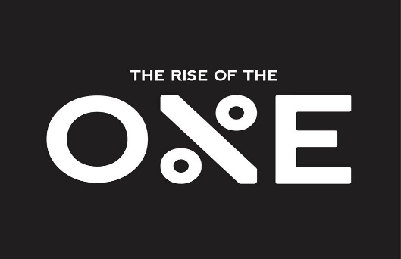
The Basic Fundamentals Of Setting Up Facebook Ads

- Setup a facebook business page the right way.
- Setup a facebook business manager account at business.facebook.com
- Create multiple Ad Accounts
- Link your facebook business page to the business manager.
- If you have a product based business you can drive traffic to your product page but your site still needs to be positioned to do upsells and potentially down-sells if you want to increase average order value.
You can also use a funnel later down the line.
If you are a service-based business you should have a funnel from the beginning.
- Setup your pixel tracking code
- Setup your custom audiences.
- Setup your custom conversions
- Create Ad Campaign. 1st Select your campaign objective
- Create Ad Sets (Targeting)
- Create Ads & Launch Ads
- Manage Ads

-Setup Campaign Objective
-Create Ad Set
Custom Audiences
Demographics
Interest:
Most Popular Books
Most Popular Influences
Most Popular News Sources
Most Popular Software
Most Popular FB Pages or Groups
Most Popular Websites

-Create Ads
7 Part Video Framework
Writing The Copy:
- Big Promise
- Big Promise With Specific Claim
- First Person Story Of Transformation
- Removal Of Pain
- Actual Client Testimonial

Writing Head-Lines

Managing Campaigns-
Pay Attention To The Metrics & Not So Much On Vanity Metrics.

-Impressions
-Reach
-Link Clicks
-Cost Per Click
-Leads
-Cost Per Lead
-Cost To Generate A Call Or Get A Call Booked
-CTR %
-Funnel Conversion %
-Relevance Score
- Cost Per Acquisition Of A Client
If you have a product-based business
Don’t worry about Leads.
Focus On Everything else up top and:
-Initiate Checkouts
-Add Too Carts
-Number Of Sales
-Cost Per Sale
-ROAS

